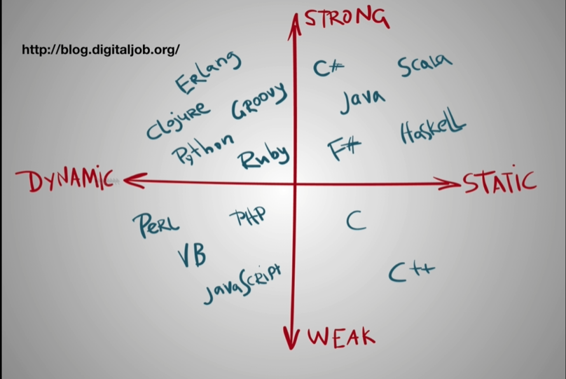

Dynamic type language doesn’t require us to specific the type of variable ( var a = 100)

Static type need:

Int a;  
 a = 100;

We need to declare it explicitly before you can use it

For dynamic type, checking is done on runtime

Pros: Statically languages are self-documented, got plugin in editor, less bugs

Cons: Harder to read, takes time to learn, slower development process, test

Pros: Dynamic – Less time debugging (mostly spend on logic), faster development

Typescript makes us use javascript like statically type, make us safer

Weakly vs Strongly Typed

In JS:

var a = “boooya”

a+17 🡸 this works, that’s what weakly typed language does

In strongly typed language you can’t do this

Static Typing in JS

Tools:

1. Reason ML – Complete separate language from JS. Different language on its own
2. Elm – Own language too.
3. Typescript – TS has its own compiler, superset of JS
4. Flow – Can add type to JS. Flow is static type checker. @flow

Their goal is to make JS nicer, less buggy and use static typing

